**02. Introduction to Kubernetes DaemonSets**

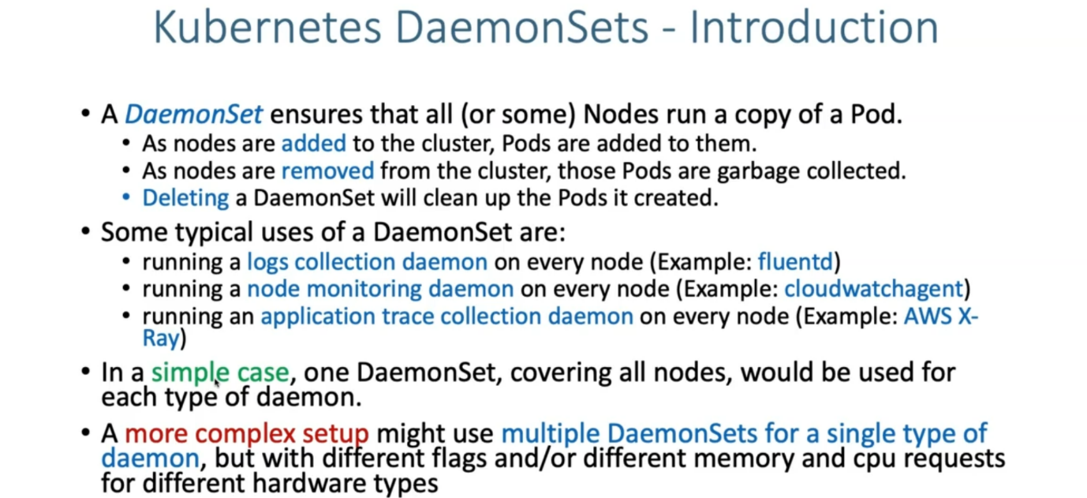

**x-ray perspective in kubernetes cluster**

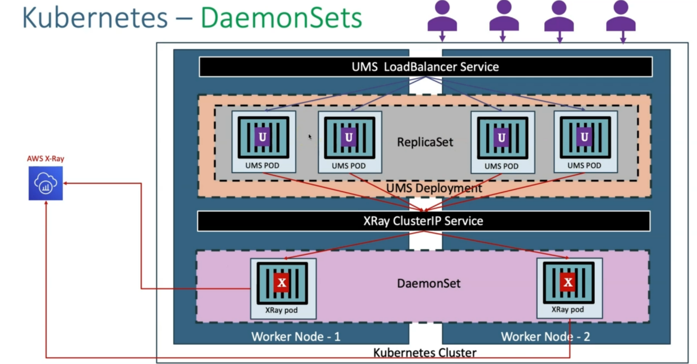

--- let's see what we are going to do from x ray perspective in kubernetes cluster. you can consider kubernetes cluster is a EKS cluster and then you have 2 worker nodes, worker Node - 1 and worker Node – 2.

--- you create a daemonsets, what it does is, that respective daemonsets is going to create a pod in each worker node, in our case, it is going to be x ray pod.

--- when applications want to send the traces to x-ray pod. we need to expose that x ray deamonset with any of the xray clusterip service. it is going to be x ray cluster IP service.

--- now, will deploy our UMS deployment application. let's consider. You have done the deployment of that ums application. it created a replica set and then created equilent pods. this you have exposed it with a load balancer to the external world.

--- now, Let's see the flow. What happens to the X-ray.

--- as a user, I tried to access my user management Microservice application and inside each ums pod, we have configured the X-ray SDK related configuration, which means these applications

are enabled with x ray related SDK features.

--- which means whatever the traffic coming to these applications, trace it and then send it to the X-ray pod.

--- whatever the application related job it has done, it will try to update the same thing to the X-ray pod, which means it is going to trace that information and then send it.

--- that request might come to any of the X-ray pod and then these X-ray pod will have the information about that.

--- it is going to send that information aws x-ray.